Experiment 6

Aim: To read an image in Python and perform erosion using the erode() function in OpenCV.

Algorithm
- Import OpenCV.
- Read the input image.
- Create a kernel.
- Apply the erosion operation using cv2.erode().
- Display the original and eroded images.
- Close all windows.

Program
import cv2
import numpy as np
img = cv2.imread("image.jpg")
kernel = np.ones((5, 5), np.uint8)
eroded = cv2.erode(img, kernel, iterations=1)
cv2.imshow("Original Image", img)
cv2.imshow("Eroded Image", eroded)
cv2.waitKey(0)
cv2.destroyAllWindows()
Output
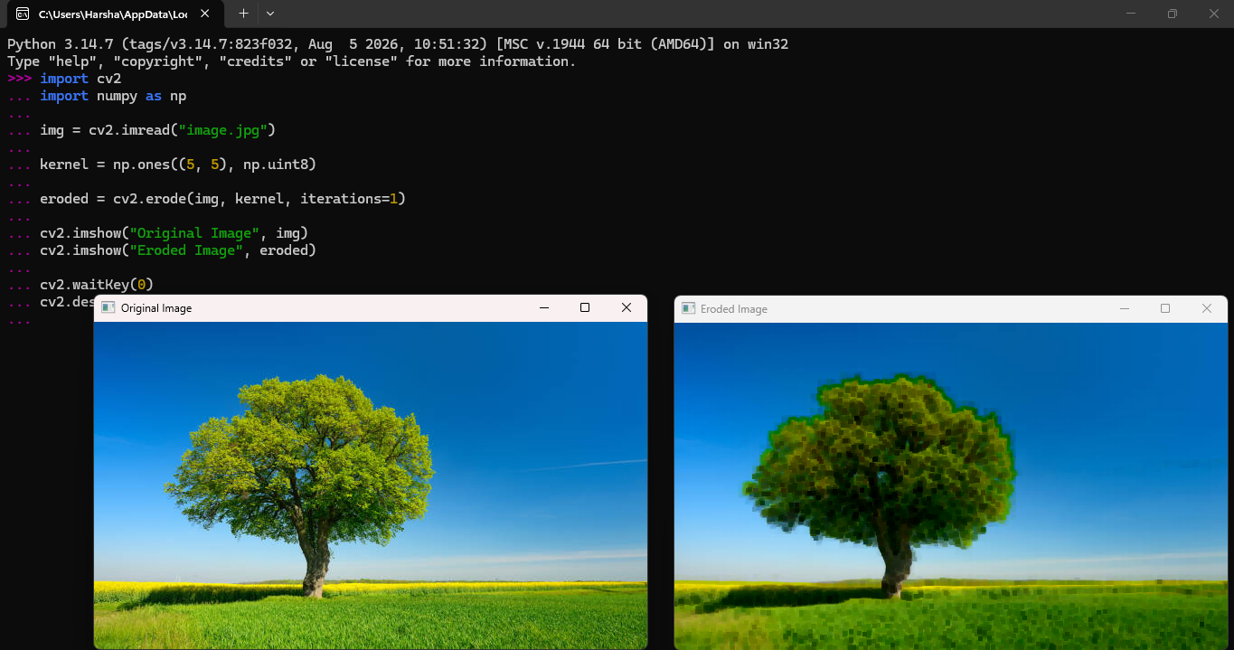

Result: Thus, the given image was successfully eroded using the cv2.erode() function.

